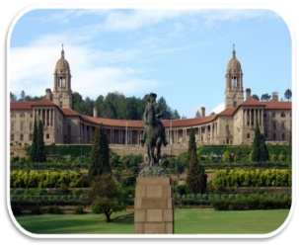

PAGE - 1 LONG WALK TO FREEDOM

Lesson & Explanation
TENTH May dawned bright and clear. For the past few days I had been pleasantly besieged by dignitaries and world leaders who were coming to pay their respects before the inauguration. The inauguration would be the largest gathering ever of international leaders on South African soil. The ceremonies took place in the lovely sandstone amphitheatre formed by the Union Buildings in Pretoria. For decades this had been the seat of white supremacy, and now it was the site of a rainbow gathering of different colours and nations for the installation of South Africa’s first democratic, non-racial government.
VOCABULARY MEANINGS:
Dawned- (of a day) began
Pleasantly- giving a sense of happy satisfaction or enjoyment; satisfying
Besieged- to be surrounded by
Dignitaries- a person considered to be important because of high rank or office.
Sandstone- sedimentary rock consisting of sand or quartz grains cemented together, typically red, yellow, or brown in colour.
Amphitheatre- an open - air theatre
Supremacy- the state or condition of being superior to all others in authority, power, or status

PARA EXPLANATION:
10th May was the day when Nelson Mandela sworn in as the first black Head of State, South Africa. It was after years of struggle that his anti-racist party came into power. Until then, the seat had always been occupied by white Presidents. That is why, the author referred to the day as “bright and clear”. It was a morning full of hope. Days before this date, many notable personalities started congratulating him for his victory. For the first time in the country’s history, so many international leaders came together for their inauguration ceremony. The ceremony took place in an open circular building made of sandstone consisting of Union buildings in the Pretoria city.

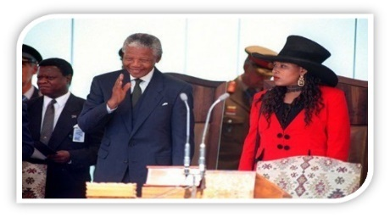
On that lovely autumn day I was accompanied by my daughter Zenani. On the podium, Mr de Klerk was first sworn in as second deputy president. Then Thabo Mbeki was sworn in as first deputy president. When it was my turn, I pledged to obey and uphold the Constitution and to devote myself to the wellbeing of the Republic and its people.
Deputy- Second in command
Sworn- given under oath; determined to stay in the role specified
Pledged- committed (a person or organization) by a solemn promise.
The author was accompanied by his daughter, Zenani on his big day. First, the two Vice-Presidents took an oath. Then, when his turn came, he committed to respect, protect and abide by the Constitution and to devote his entire self into the welfare of the country.

